Multimodal PDAC Metastatic Biomarker Discovery
  - Work Update Report 30-6-2026

The core objective is to develop a computational framework that integrates Histopathology Foundation Model embeddings with Spatial Transcriptomics (ST) to identify specific morphological features in primary pancreatic tumours that predict liver metastasis.
Crucially, the goal is to "augment" tissue embeddings during training so that, at inference time, the model can predict metastatic potential directly from H&E images without requiring ST data.

Phase A – Multimodal Embedding Alignment:
This update covers retraining of the Phase A tri-modal contrastive pipeline on the updated, filtered patch set, along with newly extracted retrieval results across five vision encoder backbones. The training methodology, architecture, and evaluation protocol are summarized below, followed by an analysis of the comparative retrieval performance.
The pipeline aligns three modalities into a shared 64-dimensional joint embedding space: vision (extracted from one of five candidate encoders: UNI2-h, H-Optimus-1, CONCH v1, CONCH v1.5, and ResNet-18, each at their native dimensionality before projection), gene expression (50-d, via scVI) and cell-type composition (15-d RCTD vectors). All modalities are aligned to 18,859 spatial spots across six patients (PT1, PT3, PT4, PT11, HM11, HM13).
The image below is the methodology diagram of Phase A:
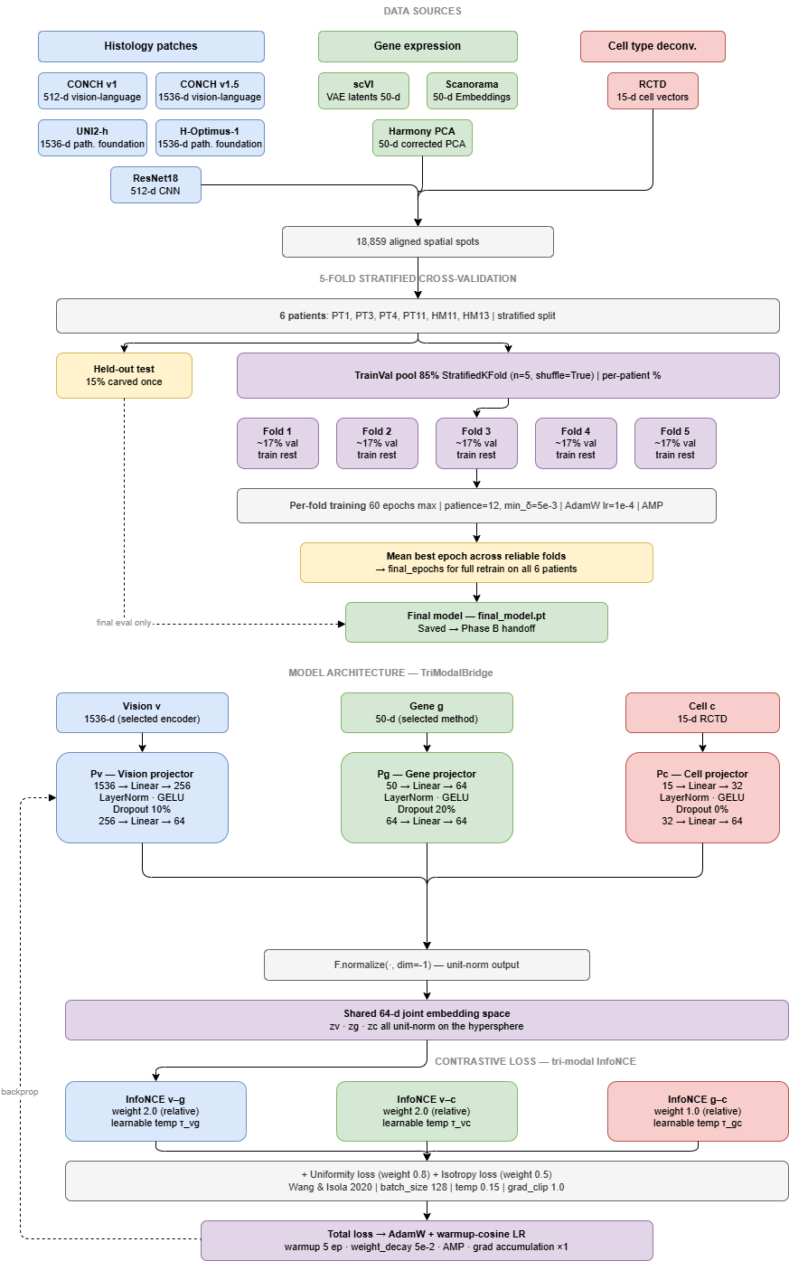
Figure 1: Phase A Methodology Diagram

The evaluation uses 5-fold stratified cross-validation with a 15% held-out test set carved once prior to fold splitting, and a stratified 85% train/val pool split per-patient across five folds (20% validation each). Each fold trains for up to 60 epochs with early stopping (patience 12, min delta 5e-3), AdamW at lr=1e-4, and automatic mixed precision. The mean best epoch across reliable folds determines the final epoch count for a full retrain on all six patients, producing the final model handed off for Phase B.
Sample | Total Spots | Test Spots | TrainVal Spots | Test%
HM11 | 3894 | 584 | 3310 | 15%
HM13 | 1387 | 208 | 1179 | 15%
PT1 | 3073 | 461 | 2612 | 15%
PT3 | 2677 | 402 | 2275 | 15%
PT4 | 4241 | 636 | 3605 | 15%
PT11 | 3587 | 538 | 3049 | 15%
Total | 18859 | 2829 | 16030 | 15%

Table 1: Per Patient Breakdown (TrainVal and Test Split)

Fold | Train | Val | HM11 val% | HM13 val% | PT1 val% | PT3 val% | PT4 val% | PT11 val%
1 | 12824 | 3206 | 20% | 20% | 20% | 20% | 20% | 20%
2 | 12824 | 3206 | 20% | 20% | 20% | 20% | 20% | 20%
3 | 12824 | 3206 | 20% | 20% | 20% | 20% | 20% | 20%
4 | 12824 | 3206 | 20% | 20% | 20% | 20% | 20% | 20%
5 | 12824 | 3206 | 20% | 20% | 20% | 20% | 20% | 20%

Table 2: Per-Fold Breakdown (Train and Validation Pool)
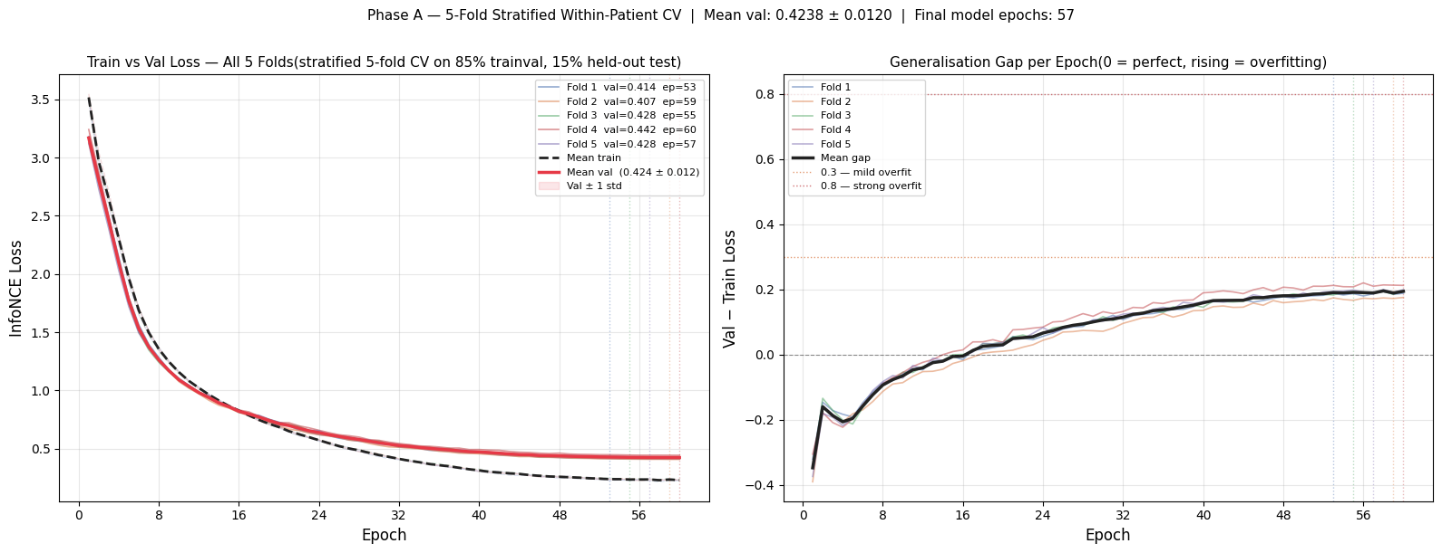
Figure 2: Training & Generalization Curve for UNI2-h model

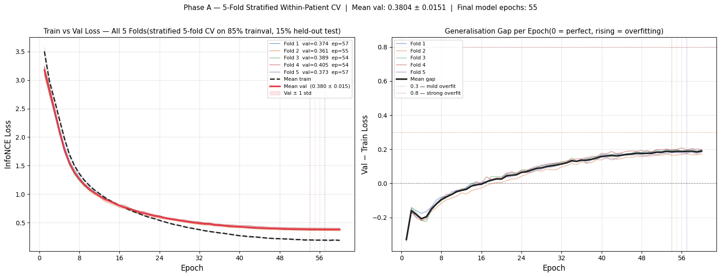
Figure 3: Training & Generalization Curve of H-Optimus-1 Model
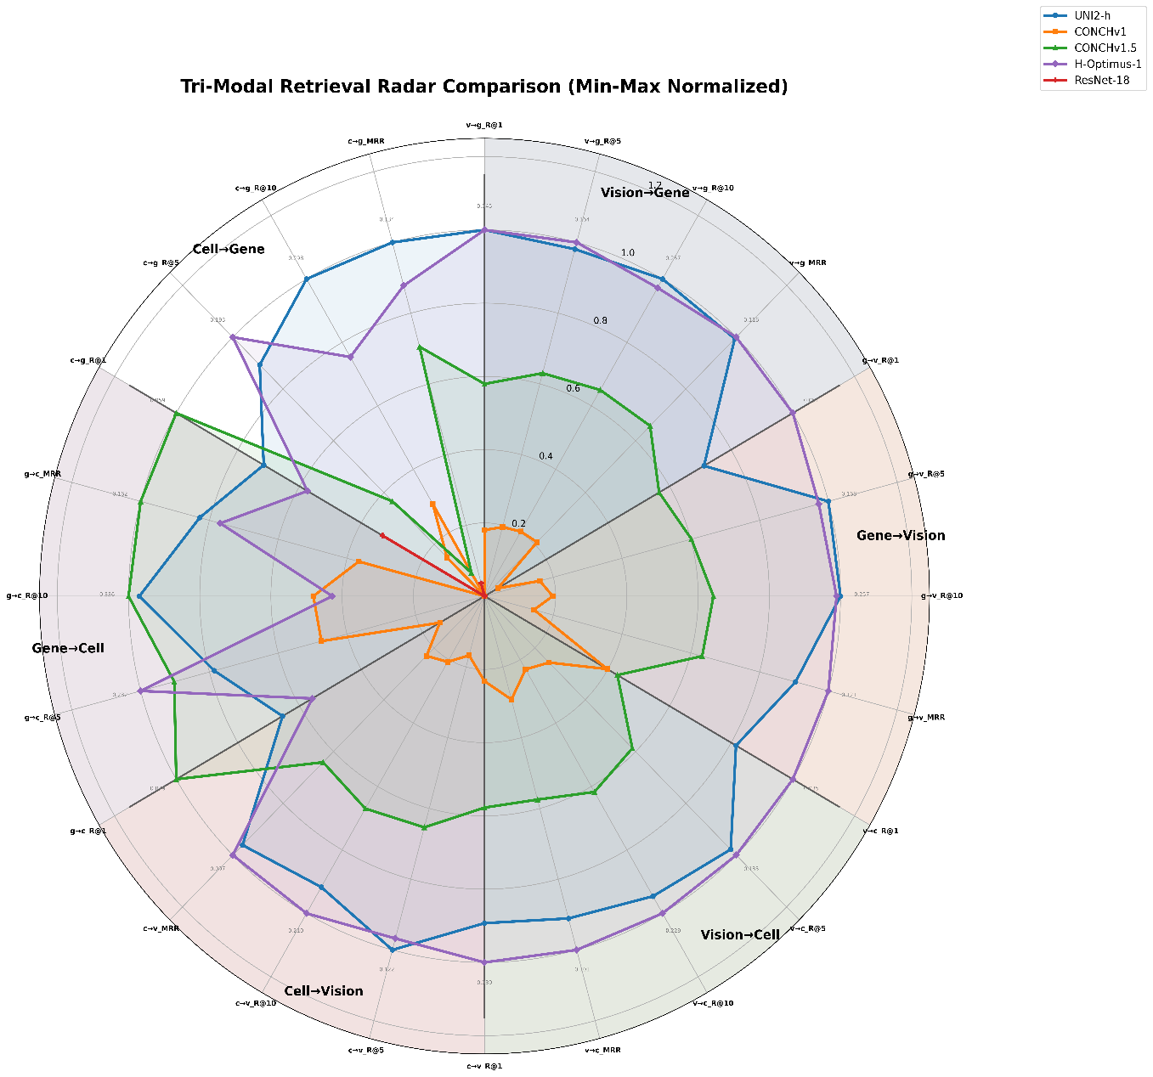
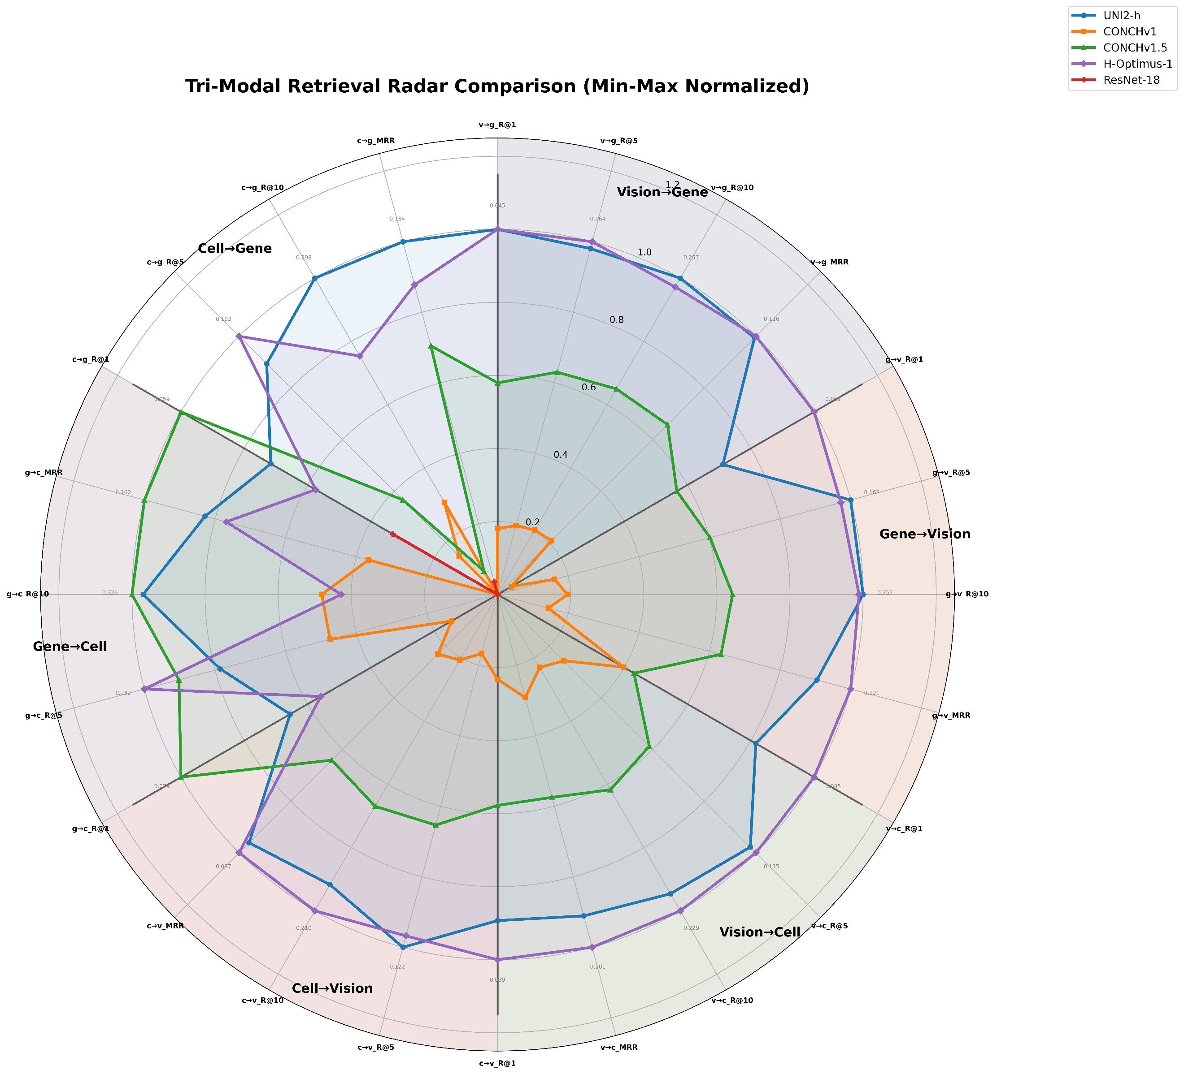
Results:
Figure 4: Radar Plot of All Vision Models trained in Phase A

UNI2-h and H-Optimus-1 are clearly the strongest performers and track each other closely across nearly every axis, both reaching the outer rings (normalized values approaching 1.0–1.2) on vision-gene retrieval in particular. CONCH v1.5 forms a consistent middle tier, visibly weaker than the two leading pathology foundation models but holding a real, non-trivial retrieval signal across all directions. CONCH v1 and ResNet-18 collapse close to the center on virtually every axis, indicating near-random or substantially degraded retrieval performance.
A directional asymmetry is visible in the shape of the polygons: vision-gene retrieval reaches the highest normalized scores for the top two encoders, while vision-cell and especially gene-cell directions show lower peak values even for UNI2-h/H-Optimus-1. This suggests gene expression aligns more readily with the vision modality than cell-type composition does, which could point to RCTD's 15-d cell vector space being a comparatively harder target to align, or to it carrying less discriminative signal for spot-level retrieval relative to gene expression.
Comments on the Training Strategy:
LOSO cross-validation was initially adopted specifically because the dataset's structure made it the theoretically "correct" choice on paper: with only six patient samples, evaluating generalization to a fully unseen patient is the most rigorous test of whether the model learns biology rather than memorizing batch-specific or patient-specific structure, and it avoids the risk of leaking spots from the same patient across train and validation splits. In practice, however, this rigor became the method's downfall. Each LOSO fold trained on only five samples and validated against one, which meant the training set lacked enough sample diversity for the model to ever separate true cross-patient biological signal from sample-specific noise, staining variation, or cohort-level batch effects.
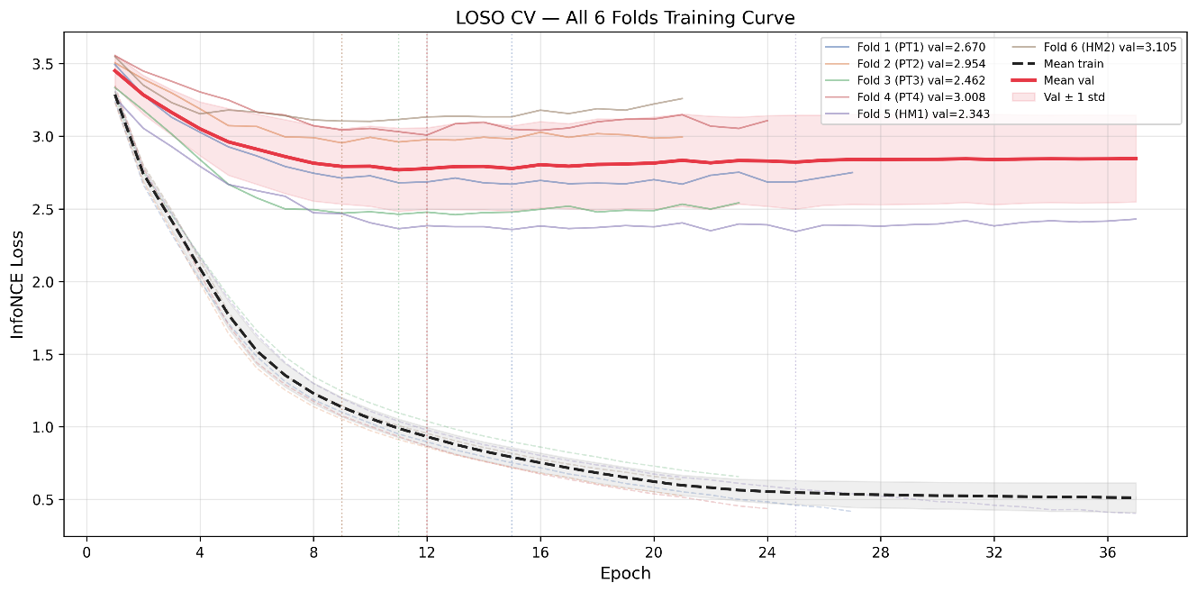
Figure 5: LOSO Training Curve for UNI2-h Model

The result, observed consistently across all six folds rather than in an isolated problem sample, was training loss that decreased normally while validation loss remained essentially flat and the train-validation gap widened progressively with every epoch — a structural small-N generalization failure rather than a tuneable hyperparameter issue, and one that no amount of additional regularization (uniformity loss, isotropy loss, projector slimming) was able to close, since those techniques address representation collapse, not insufficient sample diversity.
Stratified K-fold cross-validation was adopted as the more pragmatic alternative because it allows each fold's training set to retain a broader mix of patients and conditions (via per-patient stratified splitting) rather than ever reducing to a single sample's worth of train-set diversity, giving the model enough variation during training for validation loss to actually move in response to learning the features.

Embedding t-SNE Plots:
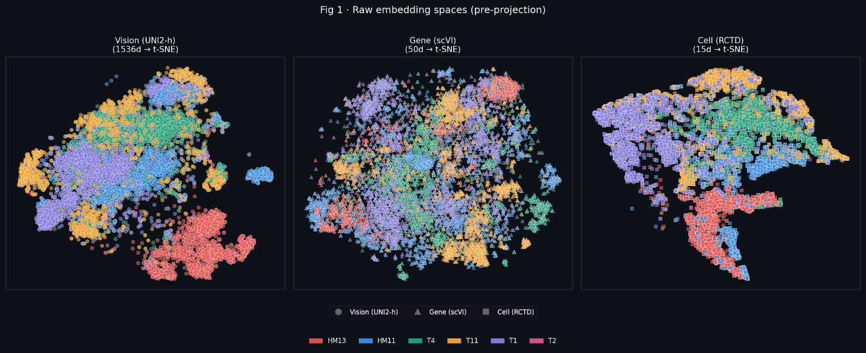
Figure 6: Raw Embeddings
Figure 6 shows each modality's native space before any learned alignment. Vision (1536-d) and RCTD cell (15-d) embeddings already show strong sample-driven clustering by patient/sample ID, most visibly HM13 (red) forming a tight, fully separated cluster from the rest in both vision and cell space. Gene embeddings (50-d, scVI) are comparatively diffuse and intermixed across samples even before projection, suggesting gene expression carries less raw sample-identity signal than the other two modalities going in.
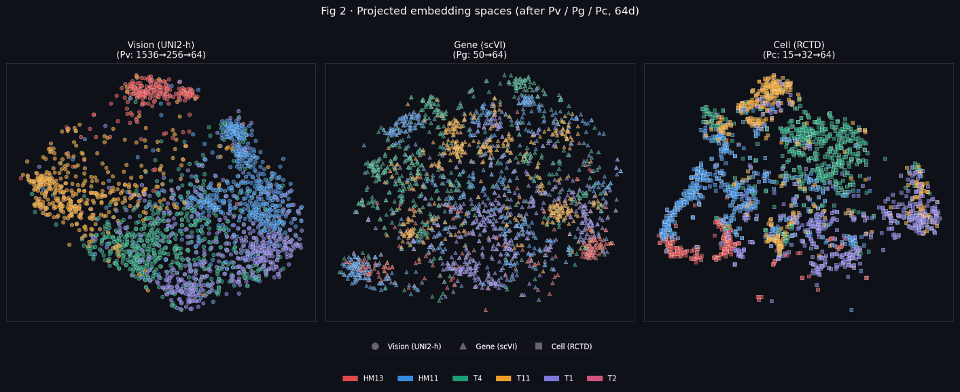
Figure 7: Projected Embeddings
Figure 7 (after Pv/Pg/Pc projection to 64-d, before contrastive loss) largely preserves this structure — vision and cell still organize by sample, gene remains the most mixed. This confirms the projectors alone aren't introducing or removing sample separation; they're just dimensionality reduction at this stage, prior to the InfoNCE objective acting on them.

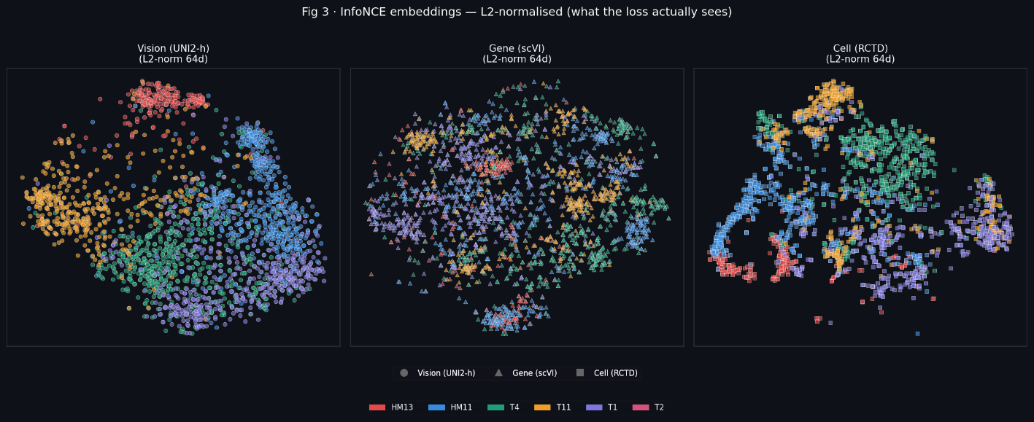
Figure 8: InfoNCE Embeddings
Figure 8 (L2-normalized InfoNCE embeddings: what the loss function actually optimizes against) is the most diagnostically important panel. Vision and cell embeddings retain clear, tight sample-ID clusters after normalization, while gene embeddings remain visibly the most entangled across samples, even post-training. This is consistent with the radar plot finding that gene-vision retrieval outperforms cell-gene and vision-cell — but it adds an important nuance: it's not that gene embeddings are poorly aligned, it's that gene embeddings may be carrying less inherently separable, sample-specific signal than vision or cell, which is a property of the modality itself rather than purely a training/alignment failure.
Why vision and cell cluster tightly by patient (sample ID) in the t-SNE plot?
Different patients' tumours just look different and are made of different cell-type mixtures overall for eg. patient HM13's tissue has its own "flavour" that's visually and compositionally distinct from patient T1's tissue, almost like how two different forests might have visibly different terrain and different mixes of tree species even if both have similar biology underneath. So, when you plot vision or cell embeddings and colour by patient, you mostly see "which forest is this," because that's the strongest, most obvious signal in those two data types.
Why doesn’t gene expression cluster as cleanly by patient?
Gene activity is driven more by what a cell is doing biologically right now (is it dividing, is it under stress, is it metastatic, is it immune-active), and these biological states can recur across different patients. A stressed, dividing tumour cell in HM13 can look genetically similar to a stressed, dividing tumour cell in T1, even though their surrounding tissue looks completely different and has a different cell-type mix. So, gene expression scatters in the t-SNE plot not because it's noisy or badly learned, but because its main organizing principle is "biological state," not "which patient," so colouring by patient ID just doesn't reveal gene's real structure.

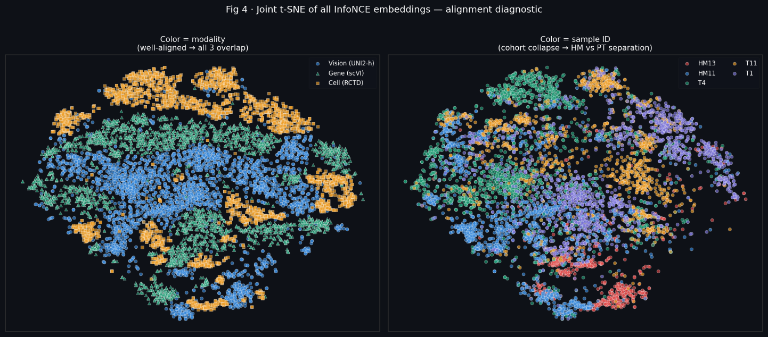
Figure 9: Joint Alignment of InfoNCE Embeddings
Figure 9 is the most useful single diagnostic in this set. When coloured by modality, the three embedding clouds overlap substantially, a genuinely good sign that the model is pulling vision, gene, and cell into a shared region of space rather than leaving them in separate silos. When the same plot is coloured by patient sample instead, HM13 reappears as a distinctly separated cluster, and a broader, partial split between HM and PT samples is visible across the rest of the space. This is the clearest visual evidence yet for the PT→HM domain shift already suspected from the retrieval numbers: the model aligns modalities reasonably well within a given patient's tissue, but which cohort a sample belongs to is still a strong, unresolved axis of variation in the learned space.

Conclusion:
Taken together, this round of work shows that the tri-modal model has learned a genuinely meaningful shared space: histology images, gene activity, and cell-type makeup overlap well when viewed together, clearly improves how well these three data types can be matched to one another. The biggest remaining problem is not random noise but a real biological pattern: gene expression reflects what a cell is doing (its activity state) and tends to look similar across patients, while what tissue looks like and what cells it contains tend to carry a strong, individual "patient signature." Because of this, the model can sometimes lean on "which patient is this" as an easy shortcut for vision and cell, while gene expression has to be matched more precisely, spot by spot, without that shortcut. This same patient signature is also the main reason validation performance struggled under the strict leave-one-patient-out testing: with only six patients, the model didn't have enough variety to tell apart, "this is a real biological pattern" from "this just happens to look like patient HM13." The clearest unresolved issue going into Phase B is that primary tumour and liver metastasis samples still don't fully overlap in the learned space, meaning the model's biggest open challenge is no longer just aligning the three data types to each other, but learning to recognize shared metastatic biology across patients rather than memorizing what each individual patient's tissue looks like.

